Blue Monkey Tea Design Guide

Logo

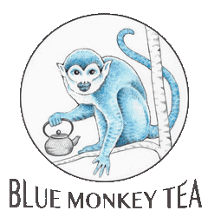

Colors:

#4db6ac #ee6e73

 

Fonts:

Verdana

Title

Heading 1

Heading 2

Heading 3

Heading 4

Heading 5

Body Text

(for ol the numbers have been taken out, it is used on the welcome page in the text about the shop)